Experiment Title 2.3

# Student Name: SANSKAR AGRAWAL UID: 20BCS5914

**Branch: CSE Section/Group:** **20BCS_MM_806-B**

**Semester: 5th Date of Performance: October 16, 2022**

# Subject Name: Multimedia Technologies Lab Subject Code: 20CSP-339

**Aim of the Practical:**

Import two pictures, one of the sea and another of the clouds. Morph, merge and overlap the images using photpea.

# Hardware Requirements:

Minimum 384MB RAM, 100GB hard Disk, processor with 2.1MHz

# Software Requirements:

Photopea

# Tools Used:

# Raster Mask, Gradient Tool (G).

**Steps for the experiment in photopea**:

**2.1 Procedure to merge two photos together**

**Step 1 :-** Create the two new projects and set the dimensions according to the requirement.

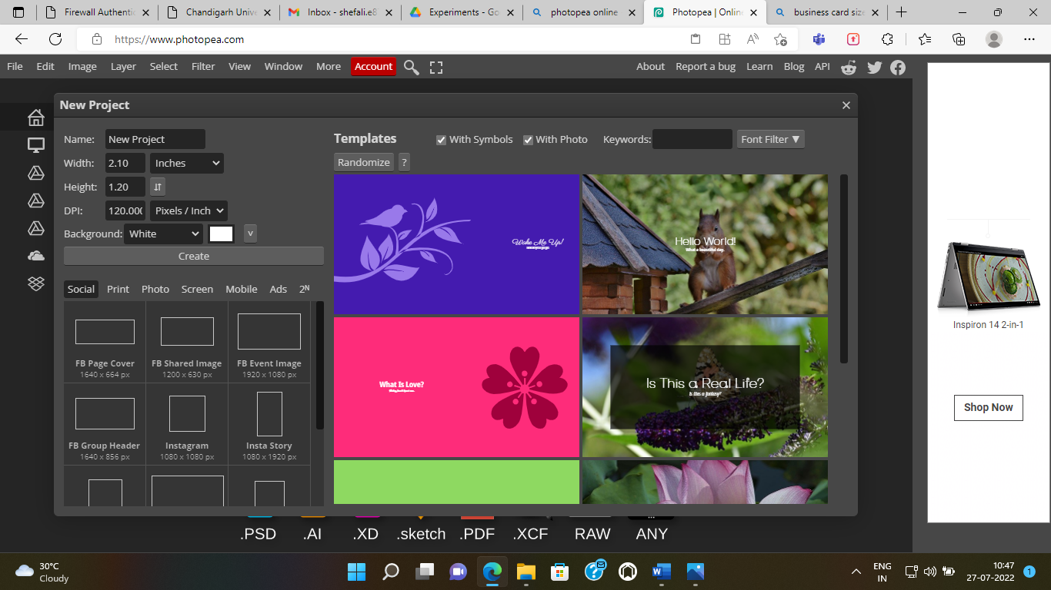

**Step 2:-** Drag one background image to another image.

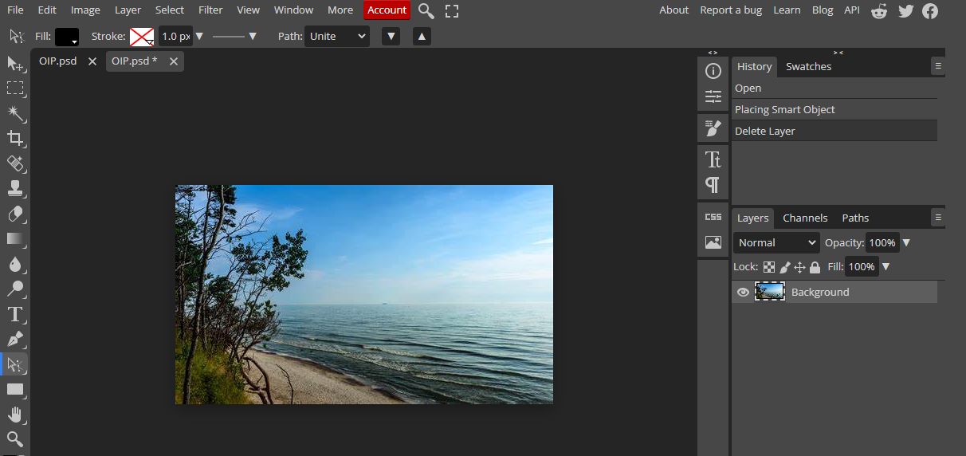

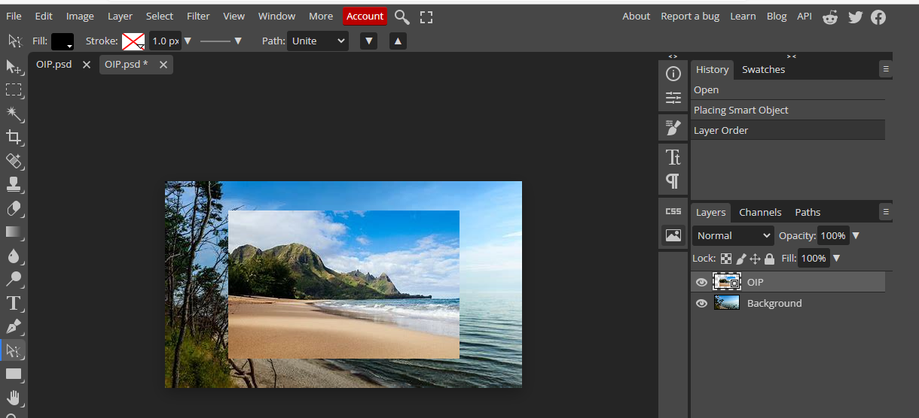

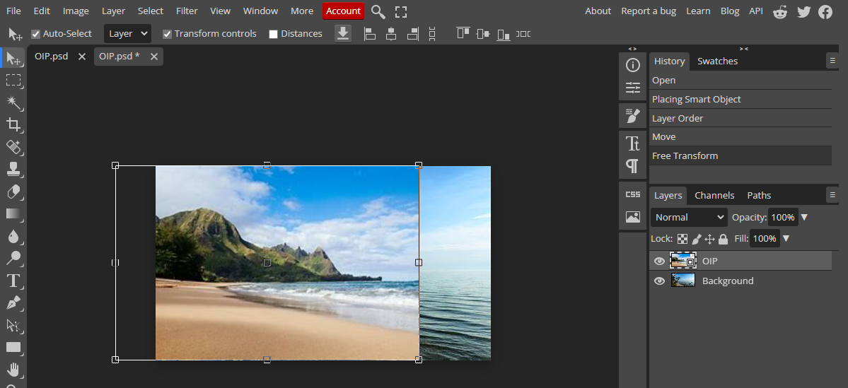

**Step 3:-** Drag the second background image over to the first image with the trees in the layers section.

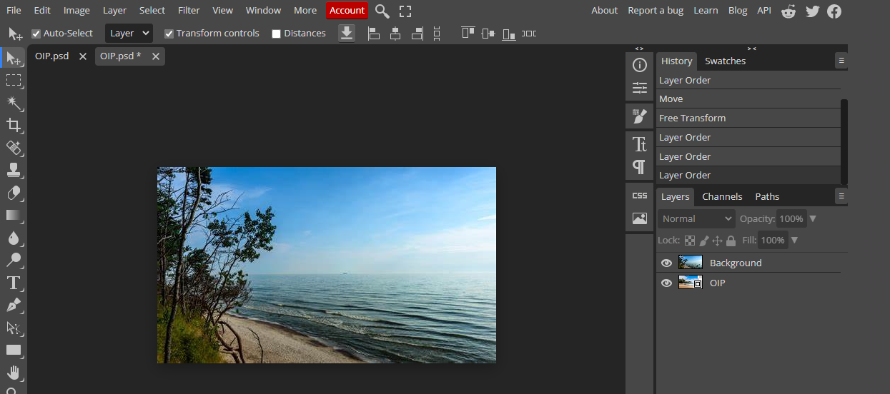

**Step 4:-** Go to Layers > Raster Mask > Add Reveal(ALL). 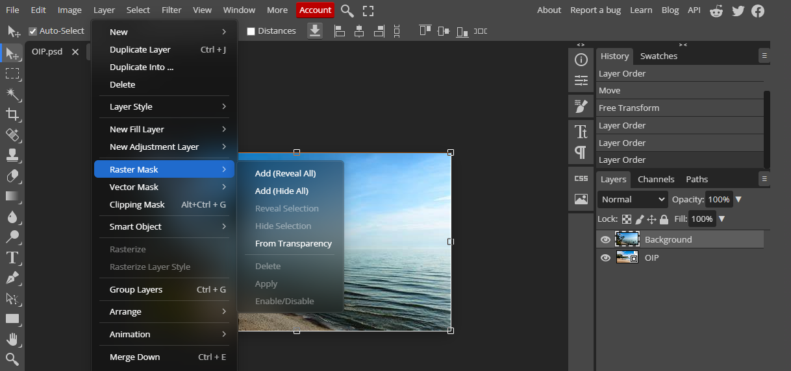 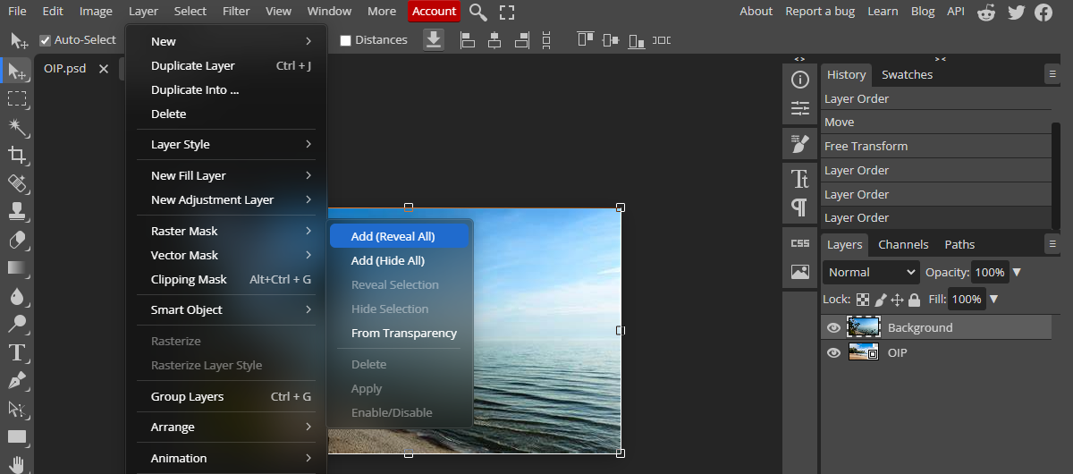

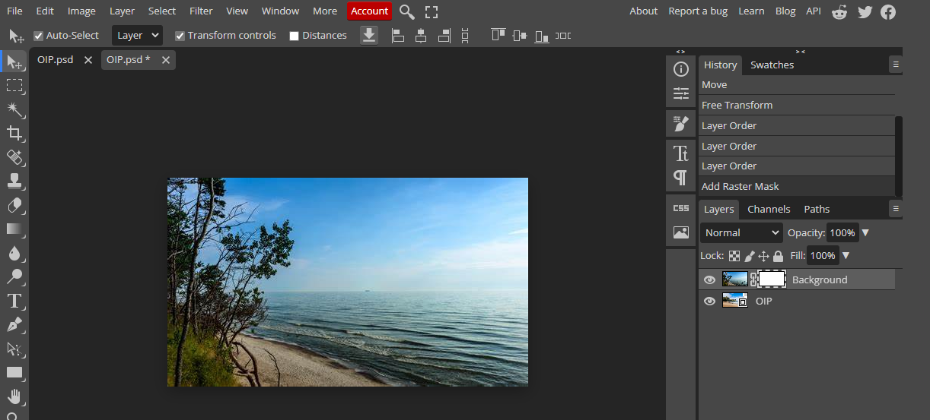

**STEP 5:-** Now select the Gradient Tool (G) from side bar.

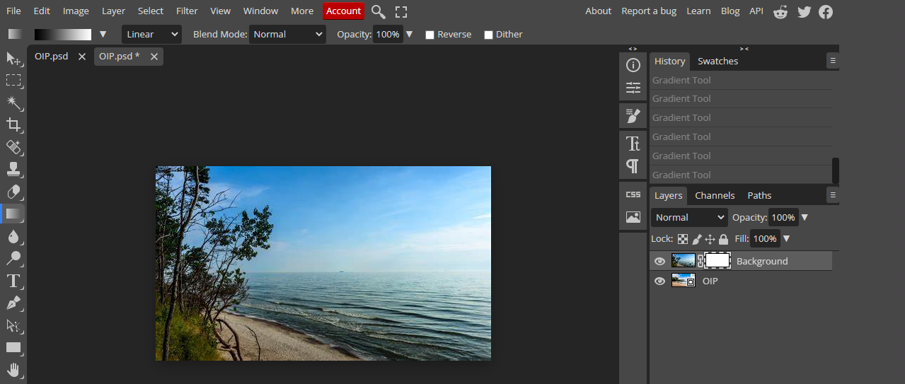

**STEP 6:-**  Now drag the line accordingly to merge the two photos as you seem good.

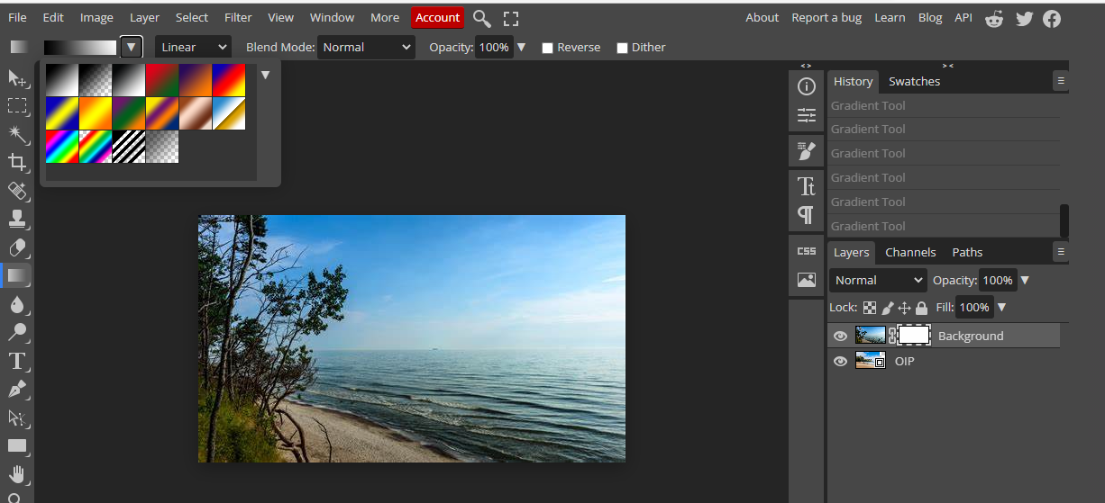

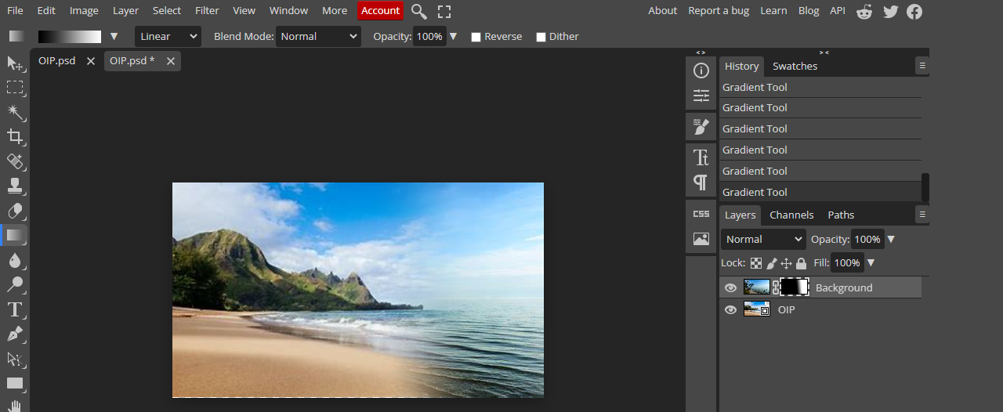

**RESULT:-**

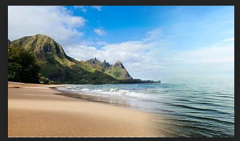

**Learning Outcomes:**

* + Learned about merging a photo with other photo.
  + how to use gradient tool and raster mask efficiently.

**Evaluation Grid (To be created as per the SOP and Assessment guidelines by the faculty):**

|  |  |  |  |
| --- | --- | --- | --- |
| Sr. No. | Parameters | Marks Obtained | Maximum Marks |
| 1. |  |  |  |
| 2. |  |  |  |
| 3. |  |  |  |